An innovative approach for computation of data in shortest paths.

Abstract:
Nowadays we use Dijkstra’s algorithm to find the shortest path in which we use the pre-defined factor weight to find the shortest path. We can find only the shortest path alone. To over come this we use two techniques called Random discretization and path delay discretization. Here we find the entire possible path using the logic given bellow. Using current node detail and the destination node is send by the source node to the neighborhood nodes. Neighborhood node receives the detail and checks for the destination node. Incase the neighborhood node is not the destination means it appends its detail along with the received details and sends to its neighborhood nodes the process continues. Till all possible path is calculated. By calculating the time delay between the two nodes (link delay) we can find the time taken by a source to reach the destination. Finally we display the entire possible path along with the time. using Random discretization and path delay discretization we can find the shortest path based on time which is useful when congestion occurs in the network. when congestion occurs in the shortest path it takes source takes more time to reach the destination .Even it take more time than the time taken by the shortest path. in our project we over come this problem.

Introduction:
A major obstacle against implementing distributed multimedia applications (e.g., web broadcasting, video teleconferencing, and remote diagnosis) is the difficulty of ensuring quality of service (QoS) over the Internet. A fundamental problem that underlies many important network function such as QoS routing, MPLS path selection, and traffic engineering, is to find the constrained shortest path—the cheapest path that satisfies a set of constraints. It is the cheapest path whose end-to-end delay is bounded by the delay requirement of a time-sensitive data flow. The additional bandwidth requirement, if there is one, can be easily handled by a pre-processing step that prunes the links without the required bandwidth from the graph. The algorithms for computing the constrained shortest paths can be used in many different circumstances, for instance, laying out virtual circuits in ATM networks, establishing wavelength-switching paths in fiber-optics networks, constructing label-switching paths in MPLS based on the QoS requirements in the service contracts, or applying together with RSVP. There are two schemes of implementing the QoS routing algorithms on routers The first scheme is to implement them as on-line algorithms that process the routing requests as they arrive. In practice, on-line algorithms are not always desired. When the request arrival rate is high (major gateways may receivethousands or tens of thousands of requests every second), even the time complexity of Dijkstra’s algorithm will overwhelm the router if it is executed on a per-request basis.1 To solve this problem, the second scheme is to extend a link-state protocol (e.g., OSPF) and periodically pre-compute the cheapest delay-constrained paths for all destinations, for instance, for voice traffic with an end-to-end delay requirement of 100 ms. The computed paths are cached for the duration before the next computation. This approach provides support for both constrained unicast and constrained multicast. The computation load on a router is independent of the request arrival rate. Moreover, many algorithms, including those we will propose shortly, have the same time complexity for computing constrained shortest paths to all destinations or to a single destination. This paper studies the second scheme. A path that satisfies the delay requirement is called a feasible path. Finding the cheapest (least-cost) feasible path is NP-complete. There has been considerable work in designing heuristic solutions for this problem. Xue [12] and Juttner et al. [13] used the Lagrange relaxation method to approximate the delay-constrained least-cost routing problem. However, there is no theoretical bound on how large the cost of the found path can be. Korkmaz and Krunz used a nonlinear target function to approximate the multi-constrained least-cost path problem [14]. It was proved that the path that minimizes the target function satisfies one constraint and the other constraints multiplied by , where is a predefined constant and is the number of constraints. However, no known algorithm can find such a path in polynomial time. Ref. [14] proposed a heuristic algorithm, which has the same time complexity as Dijkstra’s algorithm. It does not provide a theoretical bound on the property of the returned path, nor provide conditional guarantee in finding a feasible path when one exists. In addition, because the construction of the algorithm ties to a particular destination, it is not suitable for computing constrained paths from one source to all destinations. For this task, it is slower than the algorithms proposed in this paper by two orders of magnitude based on our simulations.
Literature Survey:

Approximation algorithms
In computer science and operations research, approximation algorithms are algorithms used to find approximate solutions to optimization problems. Approximation algorithms are often associated with NP-hard problems; since it is unlikely that there can ever be efficient polynomial time exact algorithms solving NP-hard problems, one settles for polynomial time sub-optimal solutions. Unlike heuristics, which usually only find reasonably good solutions reasonably fast, one wants provable solution quality and provable run time bounds. Ideally, the approximation is optimal up to a small constant factor (for instance within 5% of the optimal solution). Approximation algorithms are increasingly being used for problems where exact polynomial-time algorithms are known but are too expensive due to the input size. A typical example for an approximation algorithm is the one for vertex cover in graphs: find an uncovered edge and add both endpoints to the vertex cover, until none remain. It is clear that the resulting cover is at most twice as large as the optimal one. This is a constant factor approximation algorithm with a factor of 2. NP-hard problems vary greatly in their approximability; some, such as the bin packing problem, can be approximated within any factor greater than 1 (such a family of approximation algorithms is often called a polynomial time approximation scheme or PTAS). Others are impossible to approximate within any constant, or even polynomial factor unless P = NP, such as the maximum clique problem. NP-hard problems can often be expressed as integer programs (IP) and solved exactly in exponential time. Many approximation algorithms emerge from the linear programming relaxation of the integer program. Not all approximation algorithms are suitable for all practical applications. They often use IP/LP/Semidefinite solvers, complex data structures or sophisticated algorithmic techniques which lead to difficult implementation problems. Also, some approximation algorithms have impractical running times even though they are polynomial time, for example O(n²⁰⁰⁰). Yet the study of even very expensive algorithms is not a completely theoretical pursuit as they can yield valuable insights. A classic example is the initial PTAS for Euclidean TSP due to Sanjeev Arora which had prohibitive running time, yet within a year, Arora refined the ideas into a linear time algorithm. Such algorithms are also worthwhile in some applications where the running times and cost can be justified e.g. computational biology, financial engineering, transportation planning, and inventory management. In such scenarios, they must compete with the corresponding direct IP formulations. Another limitation of the approach is that it applies only to optimization problems and not to "pure" decision problems like satisfiability, although it is often possible to conceive optimization versions of such problems, such as the maximum satisfiability problem. Inapproximability has been a fruitful area of research in computational complexity theory since the 1990 result of Feige, Goldwasser, Lovasz, Safra and Szegedy on the inapproximability of Independent Set. After Arora et al. proved the PCP theorem a year later, it has now been shown that Johnson's 1974 approximation algorithms for Max SAT, Set Cover, Independent Set and Coloring all achieve the optimal approximation ratio, assuming P != NP.

QoS
In the field of computer networking and other packet-switched telecommunication networks, the traffic engineering term quality of service (QoS) refers to resource reservation control mechanisms rather than the achieved service quality. Quality of service is the ability to provide different priority to different applications, users, or data flows, or to guarantee a certain level of performance to a data flow. For example, a required bit rate, delay, jitter, packet dropping probability and/or bit error rate may be guaranteed. Quality of service guarantees are important if the network capacity is insufficient, especially for real-time streaming multimedia applications such as voice over IP, online games and IP-TV, since these often require fixed bit rate and are delay sensitive, and in networks where the capacity is a limited resource, for example in cellular data communication. In the absence of network congestion, QoS mechanisms are not required. A network or protocol that supports QoS may agree on a traffic contract with the application software and reserve capacity in the network nodes, for example during a session establishment phase. During the session it may monitor the achieved level of performance, for example the data rate and delay, and dynamically control scheduling priorities in the network nodes. It may release the reserved capacity during a tear down phase. A best-effort network or service does not support quality of service. An alternative to complex QoS control mechanisms is to provide high quality communication over a best-effort network by over-provisioning the capacity so that it is sufficient for the expected peak traffic load. In the field of telephony, quality of service was defined in the ITU standard X.902 as "A set of quality requirements on the collective behavior of one or more objects". Quality of Service comprises requirements on all the aspects of a connection, such as service response time, loss, signal-to-noise ratio, cross-talk, echo, interrupts, frequency response, loudness levels, and so on. A subset of telephony QoS is Grade of Service (GOS) requirements, which comprises aspects of a connection relating to capacity and coverage of a network, for example guaranteed maximum blocking probability and outage probability. QoS is sometimes used as a quality measure, with many alternative definitions, rather than referring to the ability to reserve resources. Quality of service sometimes refers to the level of quality of service, i.e. the guaranteed service quality. High QoS is often confused with a high level of performance or achieved service quality, for example high bit rate, low latency and low bit error probability. See also Relation to subjective quality measures below.

Delay Estimation

Introduction to the Non-Parametric Estimation of Delay Distribution

The goal of this work is to show how an end-to-end measurement can be used to infer per-link delay in a network. Special attention will be paid to the estimation of the probability distribution of per-link variable delay. The strategic direction is to define a logical model for the physical network, which is called the Tree model.

The focus of the estimate is not the physical propagation delay, because, usually, it does not influence the behavior of the network in a crucial way and is a more manageable value than the additional variable delay attributable to queuing in buffers or other processing in a router.

The inference strategy is aimed at the estimation of the variable delay previously mentioned and is extended from an estimate of end-to-end delays obtained by end-to-end measurements to the events of interest inside the network, such as per-link delays. Knowing these quantities, it is possible to define the delay distribution for each link by using only the measured distributions of end-to-end delay of the multicast or unicast packets.

The next section describes a logical model for studying a network topology, which is called the Tree model. A physical network is replaced by a logical tree composed of a root and the branch nodes that get down from it to the leaf receivers nodes. The root is the source, which sends the packets to a set of receivers, and the end-to-end delay is a measurement of a path from the root to a leaf receiver.

The research of distribution delay of an internal node delay is very complex. In fact, it is obtained by analyzing the different ways in which the end-to-end delay can be split between the portion of the path above or below the node in question. The key assumption is that the per-link delays between different links and packets should be considered independently. The packets are potential subject to queuing and loss over each link. That is why the probability distribution should be estimated along each link.

Due to the fact that the distribution of a link delay in the network is unknown, the characterization of the variable delay is obtained by non-parametric discrete Distributions. It also allows to obtain a broad range of different delay distributions. The model is a discrete model, because the result of the inference is a discrete probability distribution. A discretization of continuous time in a slotted time is made. Each slot consists of a bin time, which can be either fixed or variable. This approach allows to obtain the inference by simply using the algebraic computations and provides the balance between the accuracy of the distribution and the cost of calculation. The cost is inversely proportional to the bin width of the discrete distribution. The model decreases continuously until the null the width of the bin. The application of the inverse Laplace transforms makes the continuous model feasible.

In the following section 3.3 there will be described the algorithm of estimating the per-link discrete distributions by using the measured end-to-end delay distributions only. The model is based on the definition of the tree model and the likelihood function, described in the Section 2.6, under the key assumption of independent delay over each link.

The Tree Model

The tree model represents a physical network as a graph 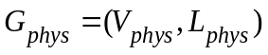. 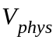 denotes the physical nodes such as routers or switches, and 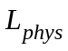 defines the link between them. A source sender probe is called a root and is labeled as 0∈. A set of receivers is denoted as R⊂. The tree model is defined by the set of paths from the root to each r∈ R and forms a tree Τphys in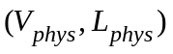.

The tree model is defined as a binary tree, where there is no possibility for two diverged paths to intersect one more time. It is possible to move from a physical model to a logical model, which is more simple to manage and takes into consideration all the characteristics of the physical one. A logical source tree can be defined Τ=(V,L).
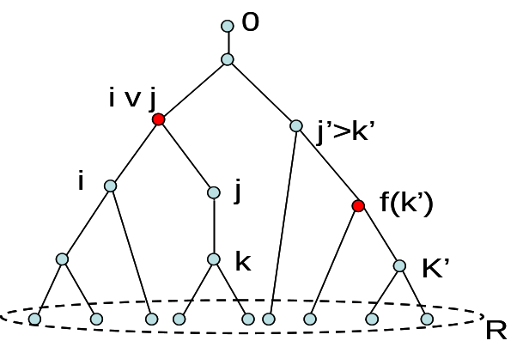

Figure 3.1: A logical tree. An ancestor j’>k’ and the first common ancestor are defined. f(k’) represents the parent of k’.
Delay model

Delay model [10] is the method to define a delay over the links or a path in a tree model. The node probe is the root. Let <i,j> be a packet pair sent to destination i and j respectively. A packet pair can be described as a train consisting of two carriages, one of which goes behind the other. They cover a common path till a branch node and are directed to nodes i and j. The common path is the sequence of a set of links down to node i v j. Let us denote p(i,j) a sequence of links traversed by at least one of the two members of the packet pair. Let k∈p(i,j) be, and denote S(k)⊆{1,2} as the set of packets which across k, where 1 and 2 are two members of packet pairs sent to i and j. 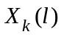, with 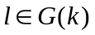is observed, and it represents the cumulated delay along the root to node k.

A measurement represents the end-to-end delay from the root to the end receivers i and j. 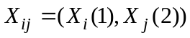expresses this couple of one way delay. Where 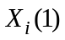 is the delay from the root to the destination i for the first member and 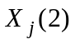 is the delay from the root to the destination j for the second member. This is the only measurement which can be used and it takes into consideration the definition of the tomography with the active external measurement (see Section 2).

It is also possible to apply a delay model to the packet pairs. Each member of a packet pair traverses a common path to arrive to the respective destination. This common path is vital for the delay model. Let 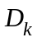 and 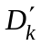 be a pair of random variable for each node k. and represents the estimated value of delay over a link (f(k),k)∈L for the first member and for the second one of the packet pair. They can have values in the real line 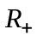∪∞. , because a delay cannot be negative. The value ∞ can be assumed if the packet is dropped on a link and is not able to reach the address receiver. For the hypothesis 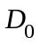=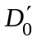equals to 0. Two kinds of independence are required for this model: for the delay between different pairs and for the delay within the same pair but over different links. For k∈V, 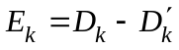 the difference between the delay experienced by the first and the second member of pair crossing k. 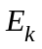 is a quantity which measures how large is the cumulated delay between two members in k.

Another hypothesis is to consider =0. This is a rough approximation. The practical application shows a different delay and≠0. The state of the network can be not stationary. When a packet is sent, it can meet different states of the network, because it is time-dependent. The first and the second member test the network in different time because they are distanced even if the temporal gap between them is small. For example, a bottleneck can have a different impact on the first and the second member of a packet pair.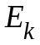can never have a null value, even if there is a perfect back-to-back packets, as, for
example, in case of a low traffic state of a network. The second member must wait the transmission of the first one. For this reason there is always a delay which is impossible to avoid.

The goal of the root is to send the pair packets. An experiment consists in sending n packets pairs <i,j> for each pair of distinct receivers i, j ∈R . Let us denote the set of measurements of this experiment by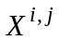:
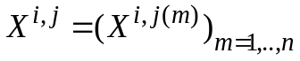
where

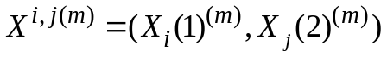
It is the delay experienced by the m-th packet pair <i,j>. To define the complete set of measurements means to group all the set of measurement for each end receivers i,j∈R

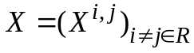
Figure 3.2 shows how the set of measurementsand the complete set of measurements X are computed.

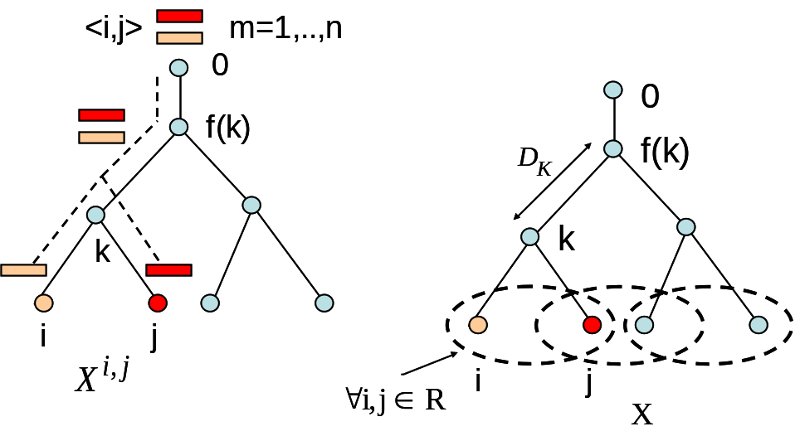

Figure 3.2: A m-th packet pair is sent to end receiver i and j. The set of measurement for m=1 to n defines. The complete set of measurement X is obtained combining all possible pair of distinct receivers i,j .

The delay analysis

The random variable can have infinite values. Some of these values have more probability than the others to be measured. The main idea is to quantify the real line ∪∞ as a finite set of possible delay Q. It is possible to group many similar delays in a unique interval. It enables to characterize the model as a discrete model. The estimation of will represent the probability distribution of these intervals. There are, in fact, some values which have more probability to be estimated and to belong to an interval than others. This model tries to estimate the discrete version of a continuous probability distribution. Actually, without a quantification, the probability distribution of is defined by an infinite number of value. Let 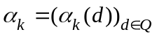 be the distribution of, where

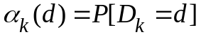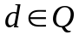

and to obtain α which is the set of distribution for each link k ∈V .
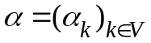

The Figure 3.3 shows a possible probability distribution of delay over link k.

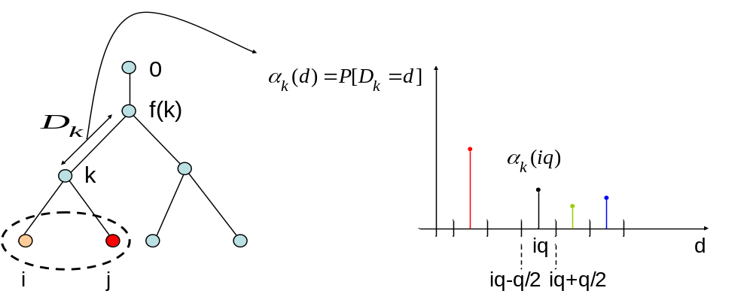

Figure 3.3: Example of probability distribution delay over link k.

Fixed Bin Size Discrete Model

Let Q be a set of finite delays. Delays are discretized to Q and takes a value in Q. Fixed bin size discrete model defines the set Q as

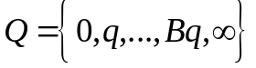
where q is a fixed bin size chosen a priori. The accuracy of the discretization depends on the choice of q. A smaller bin size provides more accuracy to the estimation of the probability distribution of . The continuous model is a case of discrete model with infinite bins obtained with 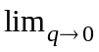 . The set Q defined in the Equation 3.6 is a finite set of values where Bq represents the greatest delay of them. The point ∞ expresses the case of packet dropped. Let us denote for each iq∈Q the interval of q-th bin as

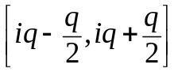 i=1,..,B
and associate the bin to the value ∞ for the case of packet lost

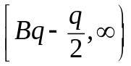
and for the case of 0, while the delay cannot have a negative value

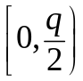

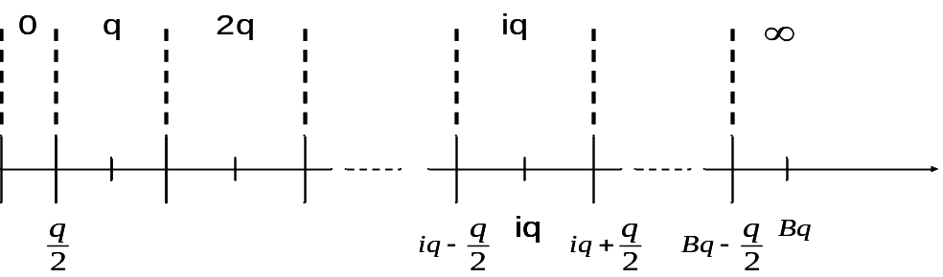
Figure 3.4: Each interval assigns a unique value to a set of values within it.
Each value contained in i-th interval will have a unique value iq. This model introduces an error of quantization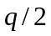. Fixed bin size discrete model is named (q,B) model for the structure of the set Q.

The estimate of α (Equation 3.5) is the goal of inference problem. It can be obtained by using the maximum likelihood approach. The set of measurements X defines the likelihood function. It is discretized to the set Q, therefore, likelihood function is a discrete function. A measurement represents two one-way delays of the first and the second members of a packet pair sent (Equation 3.2).

Figure 3.5 shows how this discretization is obtained from a continuous time.

The bidimensional discretization allows to define the space of measurement Ω. Let Ω=QxQ be the space of the possible values taken by the measurements after the discretization of the set Q. For each pair of receivers i,j it is possible to define a m-th measurement 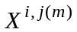=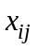∈Ω. For m=1 to n packets pair <i, j> sent a collection of measurements is made. The Figure 3.6 shows the discrete space Ω . It is important to observe that the measurements are made only when the end receivers have been chosen.

Let us denote the number of packet pairs, for which = , by 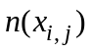. It represents a bidimensional histogram on Ω space. It depends, in fact, on the time from m=1 to n =.

Let us denote the maximum likelihood function of the measurement X by lik(X;α). Using the Equation 3.10, let L(X;α) be the log-likelihood of the measurement X.

To estimate α by using MLE, it is necessary to maximize the Equation 3.11. If the set of measurements is obtained, a function can be maximized depending on α only

The use of the Equation 3.11 does not provide a direct expression for 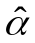. A more complex approach [11,12] can be used in the Equation 3.11 applying the Expectation Maximum algorithm. This algorithm allows to iteratively obtain α, step by step researching a local maximum of the likelihood function. Let us denote 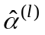the value of α at l-th step. The algorithm works until the estimated value , reaches a stationary solution.

A stationary solution is a local point of maximum of the function where the algorithm reaches the steady state 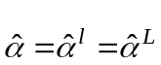. L represents the necessary steps to get the stationary solution.

The problem is that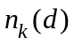 is an unknown value, which makes this approach infeasible. How can be computed if it is to infer d and its probability is to be estimated? It can be done by estimating the maximum of Equation 3.17 using the Expectation Maximum algorithm.

The EM algorithm

The Expectation Maximum algorithm [11] is used to find the local maximum point of a function. In this inference problem, the function is the maximum likelihood defined by the Equation 3.15. The unknown quantity to estimate is the delay probability distribution α. The EM algorithm adopts a dynamic analysis of the function. The research consists of many steps to obtain the exact maximum. The EM represents a model which uses the history of its research to infer the maximum in the present.

Let ranging from l=0,1,.., to a local maximization of the likelihood function be the iterative solution. l represents the l-th step of the research.

Knowing 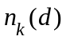 in the Equation 3.18, the delay distribution over link (f(k),k) with k∈V can be estimated. The inference target moves, therefore, to research and then, consequently, to obtain 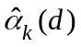. The EM algorithm requires the complete data log-likelihood 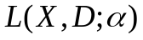 to conduct the research.

- Initialization. Select the initial delay distribution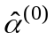. This is the choice of the starting point of the EM algorithm. can be assumed as an estimate of the approach [6].

- Expectation. Compute the conditional expectation of the log-likelihood. The quantities known are the complete set of measurement X and the current estimate . Let α’ be the probability distribution delay in this expectation.

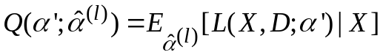 (3.19)

where the conditional expectation can be computed as

The Equation 3.20 is equivalent to the Equation 3.17. It differs only by the number 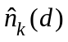 which replaces . This is the advantage, because this number can be estimated and adopted to define the likelihood function and its maximum.
The goal is to estimate the numbers by their conditional expectation under the probability law induced by with the complete knowledge of the measurements X. The computation of is equal to calculating how many times 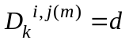,∀i,j∈R.

The conditional probability in the Equation 3.24 is not easy to calculate. It represents, i, j end receivers and their measurements being fixed, the probability distribution of D =d over the link k. It is not a static probability, since it is calculated under the law induced by . The theorem of Bayes makes the probability in the Equation 3.25 more clear

where L represents the terminal number of iterations.

Properties of EM algorithm

The EM algorithm is an important tool to solve the maximization of an inference problem. It is essential now to analyze its performance and define the degree of reliability of its results.

It is possible to estimate the quality of EM algorithm in terms of convergence and complexity.

Convergence represents the capability of EM algorithm to find the correct maximum point. The iterative analysis of converges to a stationary point α* of the likelihood function. The stationary characteristic is defined as a asymptotic property of EM algorithm [13]. The transitory time is required to reach the steady state of the solution, if it exists. This means that if the maximum is found, it satisfies

The likelihood function L(X,D;α) can have multiple stationary points, but only one of them can be the absolute maximum.

The EM algorithm could not converge to absolute maximum but only to a local maximum. There are no rules to define the conditions to reach a unique and absolute point. That is why usually converges to a stationary local point, but not necessary the absolute one. The choice of the initial conditions plays an important role in obtaining a stationary estimate. The convergence depends, in fact, on the initial distribution of α. If is far from a local point of maximum, the burden of research will be more heavy in terms of time and computation. In the worst case, a maximum cannot be reached. It is important to initialize the EM algorithm with a specific choice, which was described in the Section 2.

The complexity of EM algorithm represents the computational burden of , which requires time roughly equal to 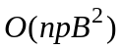[10]. The term n represents the number of packet pairs sent, p is an average number of the links between the root and the set of end receivers R, and, finally, B is the maximum interval of Q. To obtain the value of p the algorithm [14] should be applied.

The Choice of the Bin Size and the Initial Probability Distribution

The discretization introduces an inevitable quantization error. This error is function of the bin width. The Figure 3.5 shows how this error can change with the changing of the bin size. For a smaller bin the error is minor, because the original function can be recognized by the discretized function. For this reason the quality of the estimate depends on the choice of the bin size q. However, the increase in the accuracy of the estimate imposes higher computation costs. It is necessary to establish a trade-off between these two quantities. A smaller q provides better accuracy, but increases the computational cost. The complexity can be estimated as 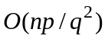, the product qB being constant, and shows how it decreases when the discretization adopts a larger bin size q. The estimate was not able to capture the right accurate delay distribution.

Another important aspect is to establish when the condition 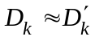 is met. It is necessary to choose a bin size which not too little. In this case, , the difference between the first and the second members of packet pair, cannot be null.

The choice of the starting delay distribution plays a very important role in obtaining the local maximum point of the likelihood function. The computation of is very complex and it is described in [6].

Let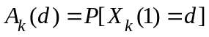, k∈V be the first member of the packet pair that arrives to the node k in a time d. 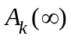 represents the probability that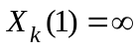. For each pair of end receivers i, j ∈R(k) the variable 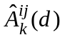 of 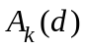 can be obtained from a distribution of the measurement 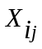 by solving a system of polynomial equations. The tree model defines f(k) as the parent of k. represents the delay between f(k) and k and is the variable to estimate. While 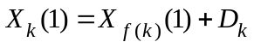, it is possible to defineif the distributions of 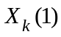 and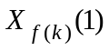 are known. In fact, their deconvolution provides the distribution of if the hypothesis of independence of and , is met. This distribution 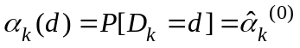 will be the initial distribution for the iterative EM algorithm. The results in [6] show that

Modules:
- Design of LAN structure
- Finding all possible path
- Time calculation
- Random discrimination

Module Description:

Design of LAN structure:
Here we design the structure for which the shortest path is to find .the structure to which we find the shortest path is drawn be
In the data flow diagram.

Finding all possible paths:
Consider a network, where is a set of nodes and is a set of directed links connecting the nodes. The delay and the cost of a link are denoted as and , respectively. The delay and the cost of a path are denoted as and , respectively. and. Let be the length (number of hops) of , and be the length of the longest path in the network. Given a delay requirement, is called a feasible path if . Given a source node, let be the set of nodes to which there exist feasible paths from . For any , the cheapest feasible path from to is defined as The delay-constrained least-cost routing problem (DCLC) is to find the cheapest feasible paths from to all nodes in which is NP-complete [19]. However, if the link delays are all integers and the delay requirement is bounded by an integer , the problem can be solved in time by Joksch’s dynamic programming algorithm [20] or the extended Dijkstra’s algorithm [17].Joksch’s algorithm is described as follows. , let be a variable storing the cost of the cheapest path from to with , and storing the last link of the path. Initially,and .NIL. Assuming that all link delays are positive, the dynamic programming is given below. Now suppose the link delays are allowed to be zero. We need to add one more step. Let be the sub graph consisting of all zero-delay links. For each , immediately after Joksch’s algorithm calculates , Dijkstra’s algorithm is executed on to improve on zero-delay paths [18].The above polynomials solvable special case with integer delays points out a heuristic solution for the general NP-complete problem with arbitrary delays. The idea is to discretize (scale and then round) arbitrary link delays to integers [15], [17], [18], [21]. There are two existing discrimination approaches, round to ceiling [17] and round to floor [18]. Both approaches map the delay requirement to a selected integer , and then discretize the link delays as follows.

Time calculation
RTC creates negative rounding errors on links. The error accumulates along a path. The accumulated error is proportional to the path length. The larger the topology, the longer a path, the larger the accumulated error. The same thing is true for RTF,which has positive rounding errors on links. In order to achieve -approximation, the accumulated error on a path cannot be too large. To reduce the error on a path, the existing algorithms based on RTC or RTF must reduce the discrimination errors on the links by using a large value. Given the time complexity proportion to .The insight is that if we can reduce the error introduced by discretization without using a larger , we can improve the performance of the algorithm.We develop two new techniques. The first one is called randomized discretization. It rounds to ceiling or to floor according to certain probabilities. The idea is for some links to have positive errors and some links to have negative errors. Positive errors and negative errors cancel out one another along a path in such a way that the accumulated error is minimized statistically. We will prove that, when the following discretization approach is used, the mean of the accumulated error on a path is zero and the standard deviation is bounded . In comparison, the mean of the accumulated error is for RTC and for RTF.

Data Flow Diagram

Node1
Node3
Node2
Node4
Node5

Technique used or algorithm used:

- RANDOMIZED DISCRETIZATION
- PATH DELAY DISCRETIZATION

Advantages:
- Shortest path is found using time.
- Shortest path varies according to the congestion occurred in the path.

Module Coding
Node 1
/****************************************************************/
/* Node1 */
/* */
/****************************************************************/
import java.awt.*;
import java.awt.event.*;
import javax.swing.*;
import javax.swing.event.*;
import java.io.*;
import java.net.*;
import java.sql.*;
/**
* Summary description for Node1
*
*/
public class Node1 extends JFrame
{
// Variables declaration
String destination;
private JTabbedPane jTabbedPane1;
private JPanel contentPane;
//-----
private JTextField jTextField1;
private JComboBox jComboBox1;
private JTextArea jTextArea3;
private JScrollPane jScrollPane3;
private JLabel jLabel1;
private JLabel jLabel2;
private JLabel jLabel3;
private JButton jButton1;
private JButton jButton2;
private JButton jButton3;
private JButton jButton4;
private JPanel jPanel1;
String str="";
String msg;
String st[]={"Select","Node2","Node3","Node4","Node5"};
String check="FIND PATH",p1,p2;
//-----
private JTextArea jTextArea1;
private JScrollPane jScrollPane1;
private JPanel jPanel2;
double time,display,calculate;
ResultSet rs;

Socket s2;
Socket s3;
Socket s4;
Socket ss1;

ServerSocket ss;

//-----
// End of variables declaration

public Node1()
{
super();
initializeComponent();
//
// TODO: Add any constructor code after initializeComponent call
//

this.setVisible(true);
try
{
ss= new ServerSocket(11);
String path=":Node1";
time=System.nanoTime();
Class.forName("sun.jdbc.odbc.JdbcOdbcDriver");
Connection con=DriverManager.getConnection("jdbc:odbc:path","sa","");
Statement stmt=con.createStatement();
stmt.executeUpdate("truncate table path");
while(true)
{

ss1=ss.accept();
DataInputStream dis=new DataInputStream(ss1.getInputStream());
display=dis.readDouble();
String check=dis.readUTF();
String dest=dis.readUTF();
String way=check+path;
calculate=time-display;

if(dest.equalsIgnoreCase("Node1"))
{
//stmt.executeUpdate("truncate table path");
stmt.executeUpdate("insert into path values ('"+way+"','"+calculate+"')");
rs= stmt.executeQuery("select * from path");
jTextArea3.setText("");
while(rs.next())
{
String p1=rs.getString(1);
String p2=rs.getString(2);
jTextArea3.append("\n------------------------------------\n Path \n----------------------------------\n"+p1+"\nConsumed Time\n"+p2);
}

//System.out.println(way+"Consumed Time\n"+calculate);
//jTextArea3.append("\n------------------------------------\n Path \n----------------------------------\n"+way+"\nConsumed Time\n"+display);
}
else
{
// System.out.println("mike testing 1");
int next[]={22,44,33};
String p[]={"Node2","Node4","Node3"};
int count=0;
String checks[]=check.split(":");
for(int j=0;j<p.length;j++)
{
for(int i=1;i<checks.length;i++)
{
if(p[j].equalsIgnoreCase(checks[i]))
{
count=1;
break;
}
else
{

count=0;
}
}

if(count==0)
{

s2=new Socket("localhost",next[j]);
DataOutputStream hit=new DataOutputStream(s2.getOutputStream());
hit.writeDouble(calculate);
hit.writeUTF(way);
hit.writeUTF(dest);

}

}
}
}
}
catch (Exception e)
{
e.printStackTrace();
}

}

/**
* This method is called from within the constructor to initialize the form.
* WARNING: Do NOT modify this code. The content of this method is always regenerated
* by the Windows Form Designer. Otherwise, retrieving design might not work properly.
* Tip: If you must revise this method, please backup this GUI file for JFrameBuilder
* to retrieve your design properly in future, before revising this method.
*/
private void initializeComponent()
{
jTabbedPane1 = new JTabbedPane();
contentPane = (JPanel)this.getContentPane();
//-----
jTextField1 = new JTextField();

jComboBox1 = new JComboBox(st);
jLabel1=new JLabel();
jLabel1.setFont(new Font("Imprint MT Shadow",Font.PLAIN,12));
jLabel2=new JLabel();
jLabel2.setFont(new Font("Imprint MT Shadow",Font.PLAIN,12));
jLabel3=new JLabel();
jLabel3.setFont(new Font("Imprint MT Shadow",Font.PLAIN,16));
jTextArea3 = new JTextArea();
jScrollPane3 = new JScrollPane();
jButton1 = new JButton();
jButton2 =new JButton();
jButton3 =new JButton();
jButton4 =new JButton();
jPanel1 = new JPanel();

//-----
jTextArea1 = new JTextArea();
jScrollPane1 = new JScrollPane();

jPanel2 = new JPanel();
//-----

//
// jTabbedPane1
//
addComponent(contentPane, jLabel3, 50,50,83,28);
jLabel3.setText(" FAST COMPUTATION OF SHORTEST PATH");
jTabbedPane1.addTab("Node1", jPanel1);
jTabbedPane1.addTab("Message", jPanel2);
jTabbedPane1.addChangeListener(new ChangeListener() {
public void stateChanged(ChangeEvent e)
{
jTabbedPane1_stateChanged(e);
}

});
//
// contentPane
//
contentPane.setLayout(null);
addComponent(contentPane, jTabbedPane1, 21,71,524,408);

//
// jTextField1
//
jTextField1.setText("");
jTextField1.addActionListener(new ActionListener() {
public void actionPerformed(ActionEvent e)
{
jTextField1_actionPerformed(e);
}

});
//
// jComboBox1
//
jComboBox1.addActionListener(new ActionListener() {
public void actionPerformed(ActionEvent e)
{
jComboBox1_actionPerformed(e);
}

});
jButton1.addActionListener(new ActionListener() {
public void actionPerformed(ActionEvent e)
{
jButton1_actionPerformed(e);
}
});

jButton2.addActionListener(new ActionListener() {
public void actionPerformed(ActionEvent e)
{
jButton2_actionPerformed(e);
}

});

jButton3.addActionListener(new ActionListener() {
public void actionPerformed(ActionEvent e)
{
jButton3_actionPerformed(e);
}

});

jButton4.addActionListener(new ActionListener() {
public void actionPerformed(ActionEvent e)
{
jButton4_actionPerformed(e);
}

});
//
// jTextArea3
//
jTextArea3.setText("");
//
// jScrollPane3
//
jScrollPane3.setViewportView(jTextArea3);
//
// jButton1
//
//jButton1.setText("jButton1");
jButton1.addActionListener(new ActionListener() {
public void actionPerformed(ActionEvent e)
{
jButton1_actionPerformed(e);
}

});
//
// jPanel1
//
jPanel1.setLayout(null);
jPanel1.setBackground(new Color(168,221,255));
jPanel2.setBackground(new Color(168,221,255));
addComponent(jPanel1, jTextField1, 19,79,150,29);
addComponent(jPanel1, jComboBox1,180,150,95,28);
addComponent(jPanel1, jScrollPane3, 310,90,184,250);
addComponent(jPanel1, jLabel1, 353,50,83,28);
addComponent(jPanel1, jLabel2, 24,145,100,28);
addComponent(jPanel1, jButton1, 105,205,145,28);
addComponent(jPanel1, jButton2,180,80,95,28);
addComponent(jPanel1, jButton3, 105,255,145,28);
addComponent(jPanel1, jButton4, 105,305,145,28);
addComponent(contentPane, jLabel3, 100,23,380,27);
//
//
//
// jTextArea1
//
//jTextArea1.setText();
jLabel1.setText("TIMINGS");

jLabel2.setText("DESTINATION");
jButton1.setText("FIND PATH");
jButton2.setText("BROWSE");
jButton3.setText("SEND");
jButton4.setText("EXIT");
//
// jScrollPane1
//
jScrollPane1.setViewportView(jTextArea1);
//
// jPanel2
//
jPanel2.setLayout(null);
addComponent(jPanel2, jScrollPane1, 39,36,430,310);
//
// Node1
//
this.setTitle("Node1 - extends JFrame");
this.setLocation(new Point(0, 0));
this.setSize(new Dimension(589, 553));
}

/** Add Component Without a Layout Manager (Absolute Positioning) */
private void addComponent(Container container,Component c,int x,int y,int width,int height)
{
c.setBounds(x,y,width,height);
container.add(c);
}

//
// TODO: Add any appropriate code in the following Event Handling Methods
//
private void jTabbedPane1_stateChanged(ChangeEvent e)
{
System.out.println("\njTabbedPane1_stateChanged(ChangeEvent e) called.");
// TODO: Add any handling code here

}

private void jTextField1_actionPerformed(ActionEvent e)
{
System.out.println("\njTextField1_actionPerformed(ActionEvent e) called.");
// TODO: Add any handling code here

}

private void jComboBox1_actionPerformed(ActionEvent e)
{
//System.out.println("\njComboBox1_actionPerformed(ActionEvent e) called.");

}

private void jButton1_actionPerformed(ActionEvent e)
{
destination =""+jComboBox1.getSelectedItem();
try
{

String path="path:Node1";
time=System.nanoTime();;
Class.forName("sun.jdbc.odbc.JdbcOdbcDriver");
Connection con=DriverManager.getConnection("jdbc:odbc:path","sa","");
Statement stmt=con.createStatement();
stmt.executeUpdate("truncate table path");
if(destination.equalsIgnoreCase("Node1"))
{ System.out.println("test");
}
else{
int port[]={22,33,44};
for(int i=0;i<port.length;i++)
{
s2=new Socket("localhost",port[i]);
DataOutputStream di=new DataOutputStream(s2.getOutputStream());
di.writeUTF("path");
di.writeDouble(time);
di.writeUTF(path);
di.writeUTF(destination);
System.out.println("Message Forward to "+port[i]+"....");
}
}

}
catch (Exception exp)
{
exp.printStackTrace();
}
}
private void jButton2_actionPerformed(ActionEvent e)
{

try
{
FileDialog o= new FileDialog(this,"open",FileDialog.LOAD);
o.show();
File fi=new File(o.getDirectory()+o.getFile());
FileReader fr=new FileReader(fi);
BufferedReader br=new BufferedReader(fr);
while((msg=br.readLine())!=null)
{
str+=msg;

}
System.out.println("----->"+str);
jTextField1.setText( ""+o.getDirectory()+o.getFile());
}
catch (Exception e1)
{
}

}
private void jButton3_actionPerformed(ActionEvent e)
{
try
{
Class.forName("sun.jdbc.odbc.JdbcOdbcDriver");
Connection con=DriverManager.getConnection("jdbc:odbc:path","sa","");
Statement stmt=con.createStatement();
String destination=""+jComboBox1.getSelectedItem();
ResultSet rs=stmt.executeQuery("select portno from port where path='"+destination+"'");
String portno="";
while(rs.next())
{
portno=rs.getString(1);
}
int por=Integer.parseInt(portno);
Socket s=new Socket("localhost",por);
DataOutputStream dos=new DataOutputStream(s.getOutputStream());
dos.writeUTF("send");
dos.writeUTF(str);

}
catch (Exception eee)
{
eee.printStackTrace();
}

}
private void jButton4_actionPerformed(ActionEvent e)
{
System.exit(0);

9.Output

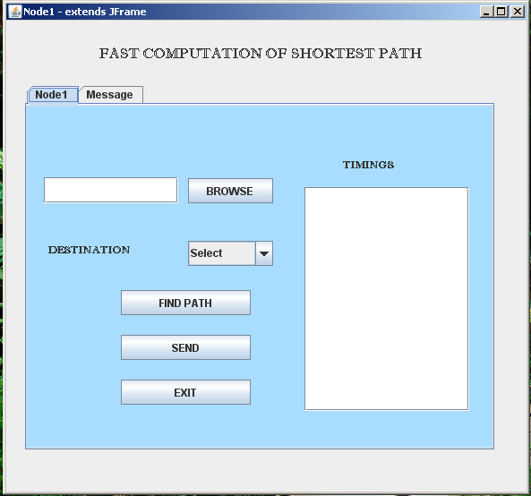

System Requirements:

Hardware:

PROCESSOR : PENTIUM IV 2.6 GHz
RAM : 512 MB DD RAM
MONITOR : 15” COLOR
HARD DISK : 20 GB
CDDRIVE : LG 52X
KEYBOARD : STANDARD 102 KEYS
MOUSE : 3 BUTTONS

Software:

FRONT END : SWINGS, JFRAMEBUILDER.
OPERATING SYSTEM : Window’s Xp
BACK END : Sql Server 2000

Conclusion:
In this paper, we proposed two techniques, randomized discretization and path delay discretization, to design fast algorithms for computing constrained shortest paths.
While the previous approaches (RTF and RTC) build up the discretization error along a path, the new techniques either make the link errors to cancel out each other along the path or treat the path delay as a whole for discretization, which results in much smaller errors.
The algorithms based on these techniques run much faster than the best existing algorithm that solves the -approximation of DCLC.

